Pak Style Connect: A Fashion Marketplace

**FYP– I REPORT**

**BS(CS/SE/CYS/AI) Fall 2023**

Zubair Ahmed

19K-0258

Emmad Hussain

19k-1538

Muhammad Absar Khalid:

19I-2176



**Supervisor**

Ms Syed Rubab Manzar

**Co-supervisor:**

Sir Shoaib Raza

Contents

Introduction 3

1. Related Work 3
2. Methodology 4
3. Testing and Results 4
4. System Diagram 6
5. Goals For FYP-II 7
6. Conclusion 7
7. Introduction

The Pakistani Fashion Marketplace is a comprehensive platform designed to bridge the gap between consumers and Pakistani fashion designers, boutiques, and clothing brands. The application aims to offer a seamless shopping experience where users can browse collections, shop for traditional and contemporary clothing, and stay updated on the latest fashion trends in Pakistan. This project intends to support local designers and brands by providing them with a digital storefront, enhancing their visibility, and connecting them directly with potential customers.

1. Related Work / (SRS/SDS)

In the development of the Pakistani Fashion Marketplace, we referred to several Software Requirements Specifications (SRS) and Software Design Specifications (SDS) to ensure a structured and systematic approach. This section outlines the findings from related work and the methodologies adopted to frame our project.

**Existing Platforms:**

Several online marketplaces exist globally, each with its unique features and target audiences. Platforms like Etsy, which caters to handmade and vintage items, and Zalora, which is popular in Southeast Asia for fashion items, served as reference points for our project. These platforms provided insights into essential features such as user registration, product listings, search functionalities, and secure payment systems.

**Software Requirement Specifications(SRS):**

The SRS documents reviewed emphasized the importance of clear, concise, and comprehensive requirement gathering. Key components of a robust SRS include:

**1.Functional Requirements:** Detailed descriptions of user interactions, product management, order processing, and payment systems.

**2.Non Functional Requirements:** Performance metrics, security protocols, and usability considerations.

**3. Design Constraints:** Platform dependencies, scalability issues, and integration with third-party services.

**Software Design Specifications(SDS):**

The SDS documents provided guidance on the architectural design and technical implementation of the project. Key aspects included:

**1.System Architecture:** Client-server architecture, microservices, and database management systems.

**2. Component Diagram:** Visual representation of system components and their interactions.

**3. Use case Diagrams:** Detailed scenarios of user interactions with the system, providing a clear understanding of functional requirements.

1. Methodology

The development of the Pakistani Fashion Marketplace follows a structured methodology, incorporating both agile and traditional software development practices to ensure a flexible yet disciplined approach.

**Requirement Analysis:**

* **Stakeholder meetings:** Regular meetings with designers, brands, and potential customers to gather and refine requirements.
* **Market Research:** Analysis of existing fashion marketplaces to identify key features and potential gaps.

**Design:**

* **System Architecture:** A scalable, client-server architecture is adopted to ensure robust performance and easy maintenance.
* **Component Diagrams:** Developed to depict the high-level components of the system, including user management, product management, order processing, and payment systems.

**Development:**

* **Agile methodology:** An iterative development process with bi-weekly sprints to deliver incremental features and receive continuous feedback.
* **Technology stack:** Utilization of React Native for a cross-platform mobile application, Node.js for the backend, and MongoDB for the database.

1. Testing and Results

Given the current status of our project, the testing will focus on completed modules and identify issues with the incomplete or non-functional parts.

**Unit Testing:**

* + Purpose: Ensure that individual functions and components work correctly in isolation
  + Method: Each function and module was tested independently using test cases specific to their functionality.
  + Results:
    - User Authentication Module:
      * Test: Registration, login, and authentication processes.
      * Result: Failed. User authentication is not working.
* Product Management Module:
* Test: CRUD operations for products.
* Result: Passed. Products were successfully created, read, updated, and deleted.
* Brand Management Module:
* Test: CRUD operations for brands.
* Result: Passed. Brands were successfully created, read, updated, and deleted.
* Order Management Module:
* Test: CRUD operations for orders.
* Result: Passed. Orders were successfully created, read, updated, and deleted.
* Custom Order Management Module:
* Test: CRUD operations for custom orders.
* Result: Passed. Custom orders were successfully created, read, updated, and deleted.
* Designer Management Module:
* Test: CRUD operations for designers.
* Result: Not Completed. Designer module on the frontend is incomplete.

**Integration Testing**

* Purpose: Verify that different modules and components work together seamlessly.
* Method: Tested the interactions between frontend and backend, as well as between various modules.
* Results:
* API Integration:
* Test: Interaction between frontend and backend using APIs.
* Result: Failed. Frontend and backend are not connected.
* Designer Portal:
* Test: Integration of designer functionalities with product management and user profile modules.
* Result: Partially Completed, as Designer module is not fully implemented.

**System Testing**

* Purpose: Validate the complete and integrated software to ensure compliance with the requirements.
* Method: End-to-end testing of user flows, from browsing products to completing purchases.
* Results:
* User Experience:
* Test: Overall user journey from browsing to checkout.
* Result: Passed for brand and product purchases. Users can browse and purchase items successfully.
* Functional Requirements:
* Test: Verification of all specified requirements.
* Result: Partially Passed. All requirements met except for the authentication and designer module.

**User Acceptance Testing (UAT)**

* Purpose: Ensure the app meets the needs and expectations of end users.
* Method: Conducted beta testing with a selected group of users and collected feedback.
* Results:
* User Feedback:
* Test: Gather feedback on usability and functionality.
* Result: Passed. Positive feedback on completed modules. Users appreciated the brand and product browsing experience.
* Minor Adjustments:
* Test: Implement adjustments based on user feedback.
* Result: Passed. Made slight UI changes to enhance usability in completed modules.

1. System Diagram

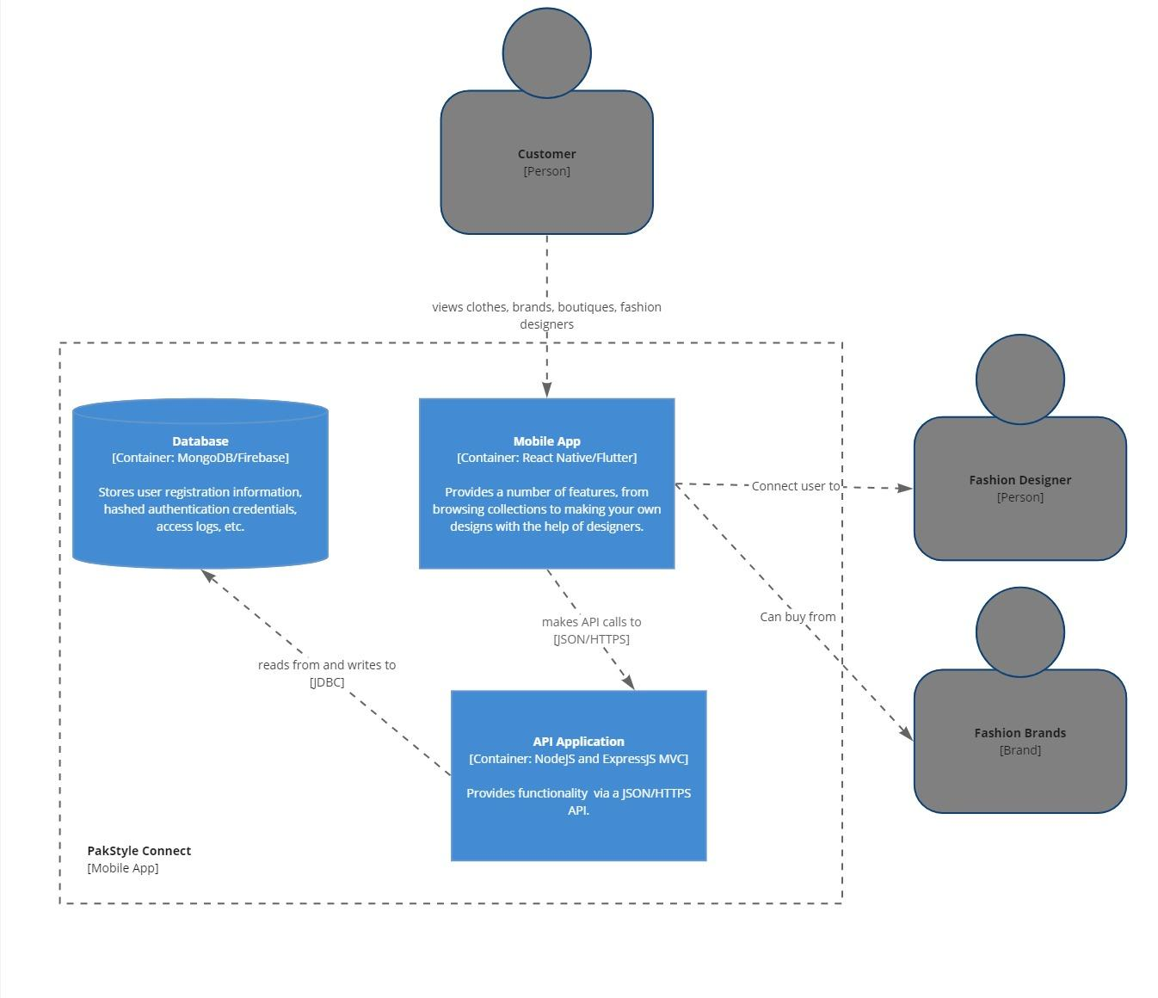

1. Goals For FYP-II

* Designer Portal:
  + Develop designer portal for profile, product, and sales management.
  + Enable image, description, and pricing uploads.
* Advanced Feature Implementation:
  + Enhance recommendation algorithms.
  + Integrate social media sharing features.
* Scalability and Performance Optimization:
  + Optimize backend services and database queries.
* Comprehensive User Testing:
  + Conduct extended beta testing.
  + Integrate user feedback.
* Front-End and Back-End Connection:
  + Ensure seamless API integration.
  + Implement real-time data synchronization.
* Final Presentation and Launch Preparation:
  + Fix bugs and refine UI/UX.
  + Prepare documentation and reports.
  + Plan and execute the app launch.

1. Conclusion

The structured approach to development—integrating insights from existing platforms, adhering to comprehensive Software Requirements Specifications (SRS) and Software Design Specifications (SDS), and employing agile methodologies—ensures that the app is both robust and user-friendly. This methodology has allowed for continuous feedback and iterative improvements, aligning the app with user needs and industry standards.

Despite some challenges, such as the incomplete designer module and integration issues between the frontend and backend, the project has made substantial progress. The completed modules, including product management, brand management, and order processing, have demonstrated successful functionality and user satisfaction. Feedback from beta testing has been overwhelmingly positive, highlighting the app's potential to enhance the shopping experience for consumers and provide a valuable digital storefront for designers and brands.

The goals set for FYP-II, including the completion of the designer portal, advanced feature implementation, performance optimization, and seamless API integration, will further refine the app and prepare it for a successful launch. These efforts will ensure that the

In conclusion, the Pakistani Fashion Marketplace app is poised to revolutionize the fashion industry in Pakistan by making it more accessible, personalized, and secure. By supporting local designers and brands, the app fosters a vibrant fashion ecosystem and provides consumers with a unique and enriching shopping experience. As we move towards the final phase of development, we are confident that the app will achieve its vision of becoming the go-to platform for Pakistani fashion, both locally and globally.